FOOD FOREST MODEL OF ORGANIC FARMING – A REAL LIFE VALIDATION

Cyclone Nivar just went past us in Pondicherry with all its fury over the last two days.
The rainfall in just one night was over 350 mm …. That is equivalent of almost 25% of average annual rainfall of Pondicherry.
The windspeed was upward of 100 kmph for some time.

Yet, this cyclone has given us, at Gratitude Farms, a huge validation of our “Food forest” model of organic farming that we are developing for the small and marginal farmers to take up organic farming in a sustainable way.

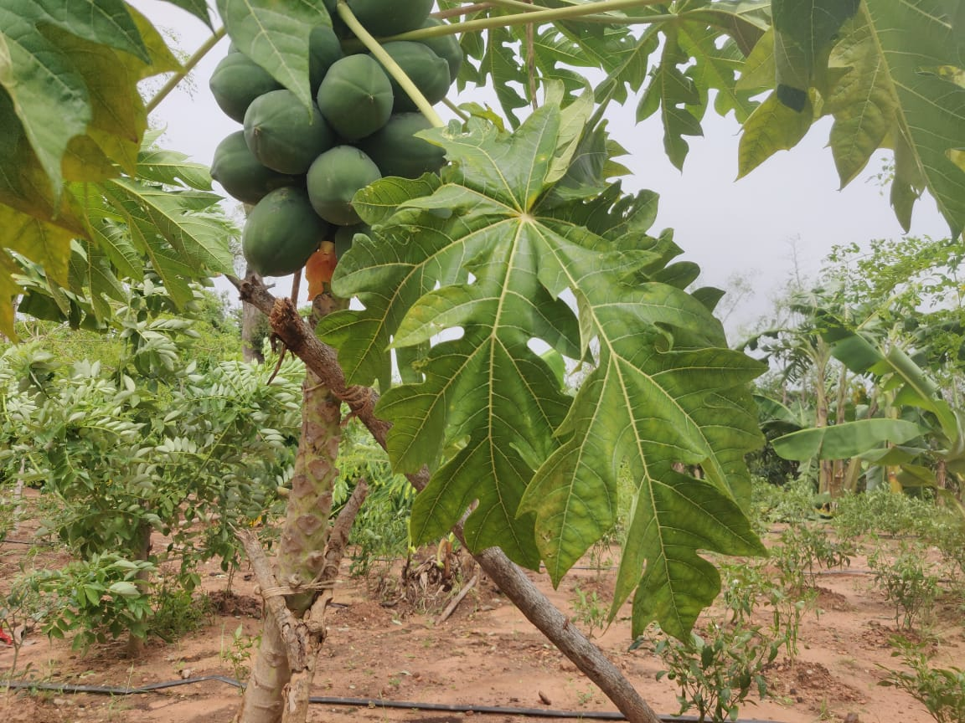
- Less than 2% fruit trees fell. We had minimal damage to fruit trees and our plants:
  - In four of our five farms under full food forest implementation, we have over 1000 fruit trees and over 40,000 vegetable plants.
  - Only 16 trees have fallen down and another 20 have been partially uprooted from roots (they can be restored as the trees and roots are intact).
  - Most of our vegetable plants, trellis-based plants and greens have survived the wrath of nature, in no small measure, protected by the wind-breaking effect of the trees around them.

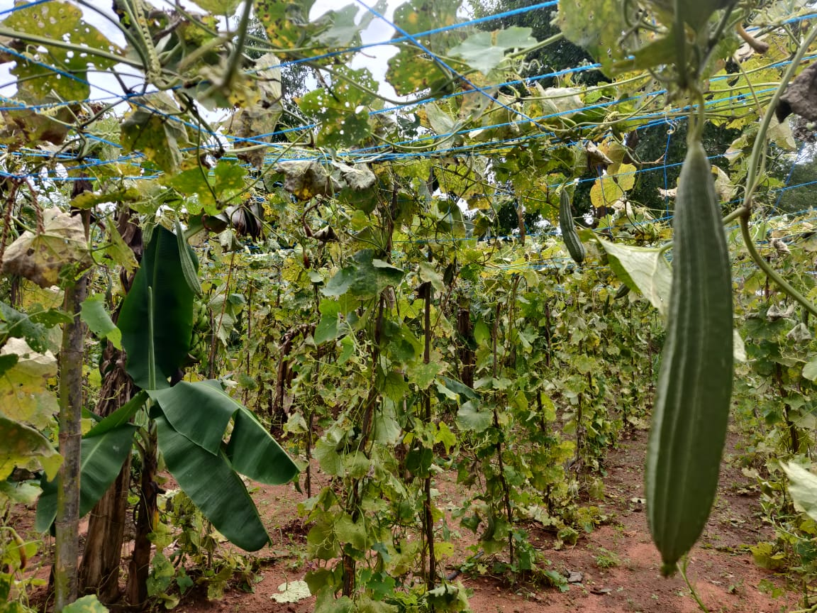
- No water-logging. We have almost no water logging in our farmlands, thanks to the gradient based beds and channeling of surplus water for ground re-charge.

- Composting onsite. What is more, every tree, every leaf that has fallen down, we will be using it for making compost in house.

What is Food-Forest Model of Organic Farming?

It has been adopted from the age-old practice of multi cropping in small farmlands, and synthesised with concepts of designing the farmland for high-yield and risk mitigation from pest attacks and cyclonic storms.

Key design elements for Food Forest Model of Organic Farming
If our Food-Forest Model design has been able to survive the fury of Cyclone Nivar, we can take confidence that the model should be able to face most of the storms anywhere in the country, as we replicate it in other parts over the coming years.

Thanks to all our mentors, teachers and our team-members who have helped us in designing and implementing the concept of Food- Forest Model. We continue to learn each passing day and making it better, for you see….

Every acre of land that we can convert to organic is a service to The Mother Earth

